
Chair’s Report
2020 AGM

From: Ann Doggett, Chair, Field Hockey Canada Board of Directors
Attn: Field Hockey Canada Member PSOs
Date: August 14, 2020
_________________________________________________________________________________________

The year since the last AGM has been an eventful one in all aspects: financial change, new staff, Olympic qualifiers, and a new world normal due to Covid. Looking forward to 2020/2021 the board will be welcoming four new directors, continuing to manage our resources to ensure we move to financial health, and implementing recommendations from the high-performance review.

2019/2020 highlights:
- Improved financial status due to the diligence of all, but especially of our CEO and Treasurer. Full details are outlined in the Treasurers Report and audited Statements
- Women’s and the Men’s National Teams competing at the Olympic Qualifiers. Both against Ireland and both needing to go the distance to heart stopping video replay shoot outs. The men qualifying and the women looking forward to the next challenges.
- A comprehensive high-performance review
- Excellent work done by our committees and active support by all directors.
- Regular PSO meetings
- Return to Play guidelines
- Securing pandemic insurance coverage
- Update of FHC policies
- Introduction of FHC Coaching Awards in conjunction with National Coaches Week

Thanks to all directors and our CEO Susan, for the tremendous amount of work and dedication during this past year. It was an eventful and productive year.

A thank you to all the chairs and the members of our ad hoc committees. The chairs work with the Board and the CEO to help achieve our strategic goals.
- Hall of Fame: Dr. Sue Neill
- Coach Education Committee: Jenn Began
- Officials: Laurie Hogan and outgoing long-time chair Paula Parks
- U sports: ???
- Masters: Ian Baggott
- Indoor: Derm Coombs

I would like to take this opportunity to deliver a special thank you to Ian Baggott and Gordon Plottel outgoing board members for their years of service and dedication to Field Hockey Canada. Their passion and commitment have been evident in all the work and support they have provided during their time of the board. They will be missed at Field Hockey Canada, but I am sure they will continue working to support our game.

Thanks Ian. Thanks, Gord.

Sincerely,

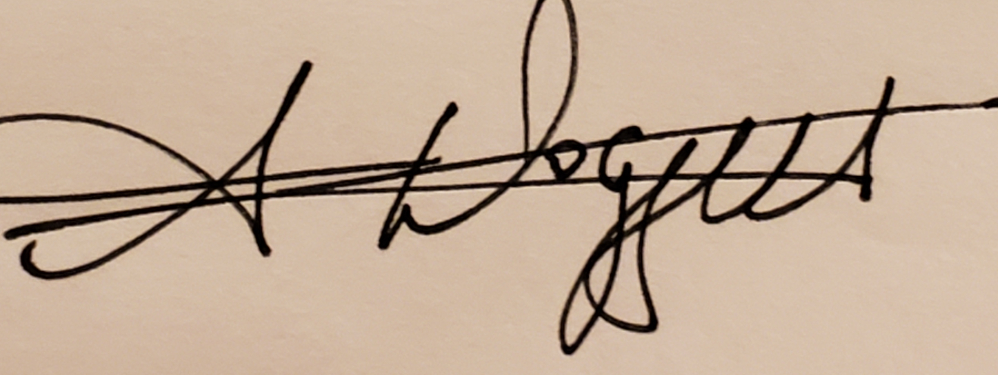

Ann Doggett
Chair, Governance Committee

